# American Sign Language Detection

* In this project, I have created a model that will predict the hand signs based on the American Sign Language(ASL) standards.
* The dataset is taken from Kaggle and it has a total of 36 classes including images of the numbers from 0-9 and all the English alphabets from A-Z. It has around 2515 images in total and around 70 images in each class.
* I have split the dataset into training and testing sets where there are 2012 images for training (55 images in each class) and 503 images for testing (14 images in each class).

Dataset Link:<https://www.kaggle.com/datasets/ayuraj/asl-dataset>

## Importing the required libraries

|  |
| --- |
| import cv2 as cv import pandas as pd import numpy as np import matplotlib.pyplot as plt import seaborn as sns from sklearn.metrics import confusion_matrix, ConfusionMatrixDisplay import os  from tensorflow.keras.layers import MaxPooling2D, Dense, Flatten, Dropout from tensorflow.keras.models import Model  from tensorflow.keras.applications import InceptionV3 from tensorflow.keras.models import Sequential from tensorflow.keras.preprocessing import image from tensorflow.keras.preprocessing.image import ImageDataGenerator from tensorflow.keras.optimizers import Adam from tensorflow.keras.losses import CategoricalCrossentropy from tensorflow.keras.metrics import CategoricalAccuracy from tensorflow.keras.models import load_model |

In [1]:

Setting the path of the training and testing dataset

|  |
| --- |
| train_path = "dataset/train" test_path = "dataset/test" |

In [2]:

## Performing data augmentation

* Using ImageDataGenerator we rescale the images and and also artificially create different training and testing images through different ways of processing like shear and zoom. This introduces a sort of randomness in the dataset.

|  |
| --- |
| train_datagen = ImageDataGenerator(rescale = 1/255,  shear_range=0.2,  zoom_range=0.2) test_datagen = ImageDataGenerator(rescale = 1/255, |

In [7]:

shear_range=0.2,

zoom_range=0.2)

|  |
| --- |
| train_set = train_datagen.flow_from_directory(train_path,  target_size = (224, 224), batch_size = 32, class_mode = 'categorical')  test_set = test_datagen.flow_from_directory(test_path,  target_size = (224, 224), batch_size = 32, class_mode = 'categorical') |

In [8]:

Found 2012 images belonging to 36 classes. Found 503 images belonging to 36 classes.

|  |
| --- |
| y_train = train_set.classes y_test = test_set.classes  train_set.class_indices |

In [9]:

Out[9]: {'0': 0,

'1': 1,

'2': 2,

'3': 3,

'4': 4,

'5': 5,

'6': 6,

'7': 7,

'8': 8,

'9': 9,

'a': 10,

'b': 11,

'c': 12,

'd': 13,

'e': 14,

'f': 15,

'g': 16,

'h': 17,

'i': 18,

'j': 19,

'k': 20,

'l': 21,

'm': 22,

'n': 23,

'o': 24,

'p': 25,

'q': 26,

'r': 27,

's': 28,

't': 29,

'u': 30,

'v': 31,

'w': 32,

'x': 33,

'y': 34,

'z': 35}

## Plotting sample images from the training dataset

|  |
| --- |
| label_names = ['0', '1', '2', '3', '4', '5', '6', '7', '8', '9', 'A', 'B',  'C', 'D', 'E', 'F', 'G', 'H',  'I', 'J', 'K', 'L', 'M', 'N', |

In [10]



|  |
| --- |
| imgs, labels = next(iter(train_set)) counter = 1 for img, label in zip(imgs, labels):  plt.subplot(5,5,counter)  plt.subplots_adjust(right=5, top=5, wspace=0.5, hspace=0.5) value=np.argmax(label) labelname=label_names[value] plt.imshow(img)  plt.title("Image of: "+labelname, fontdict={'fontsize': 25}) counter+=1 plt.axis("off") if(counter>10):  break  plt.show() |

In [11]:

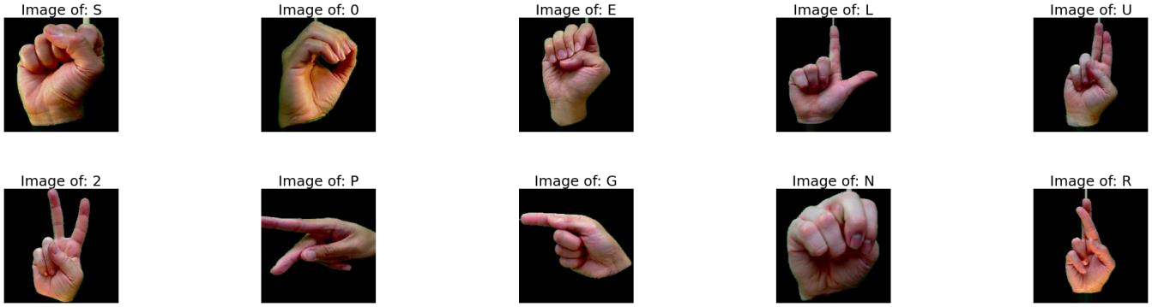

# Creating the model

## InceptionV3 transfer learning

* Transfer learning is a machine learning method where a model developed for a task is reused as the starting point for a model on a different task. So an already trained model on some other dataset is used and modified to fit the new task.
* Inception v3 is an image recognition model that has been shown to attain greater than 78.1% accuracy on the ImageNet dataset. The model is the culmination of many ideas developed by multiple researchers over the years.

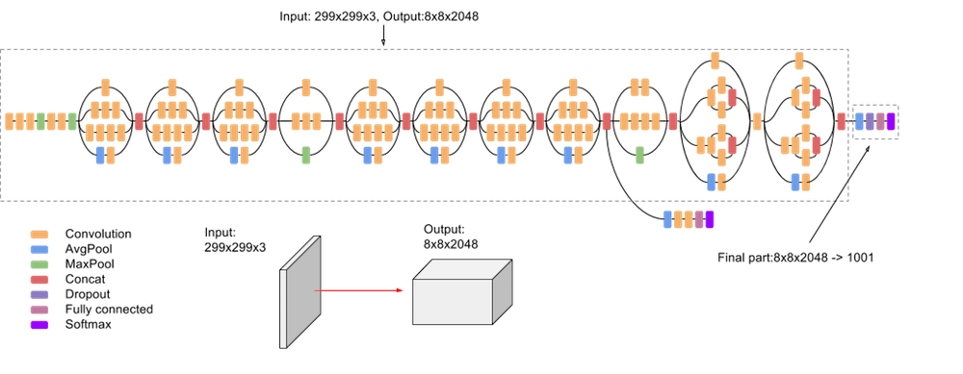

### Loading inceptionV3 as the base model

|  |
| --- |
| base_model = InceptionV3(input_shape=(224,224,3),  include_top=False, weights = "imagenet") |

In [12]:

|  |
| --- |
| base_model.trainable = False |

In [13]:

### Adding the base model and a few layers to our model

|  |
| --- |
| model = Sequential([ base_model,  MaxPooling2D(),  Flatten(),  Dense(36, activation="softmax")]) |

In [14]:

|  |
| --- |
| model.summary() |

In [15]:

Model: "sequential"

Layer (type) Output Shape Param #

=================================================================

inception_v3 (Functional) (None, 5, 5, 2048) 21802784

max_pooling2d_4 (MaxPooling (None, 2, 2, 2048) 0 2D)

|  |  |  |
| --- | --- | --- |
| flatten (Flatten) | (None, 8192) | 0 |
| dense (Dense) | (None, 36) | 294948 |

=================================================================

Total params: 22,097,732

Trainable params: 294,948

Non-trainable params: 21,802,784

### Compiling and fitting the model on the training dataset

|  |
| --- |
| model.compile(optimizer=Adam(learning_rate = 0.01),  loss = CategoricalCrossentropy(), metrics = [CategoricalAccuracy()]) |

In [16]:

|  |
| --- |
| model.fit(train_set,  validation_data = test_set, steps_per_epoch = 32, epochs = 32) |

In [21]:

Epoch 1/32

32/32 [==============================] - 114s 4s/step - loss: 75.7752 - categorica l_accuracy: 0.2549 - val_loss: 26.1806 - val_categorical_accuracy: 0.5229

Epoch 2/32

32/32 [==============================] - 132s 4s/step - loss: 11.3058 - categorica l_accuracy: 0.6520 - val_loss: 6.3638 - val_categorical_accuracy: 0.7555 Epoch 3/32

32/32 [==============================] - 160s 5s/step - loss: 7.4541 - categorical _accuracy: 0.7431 - val_loss: 6.3073 - val_categorical_accuracy: 0.8231

Epoch 4/32

32/32 [==============================] - 157s 5s/step - loss: 6.0897 - categorical _accuracy: 0.8157 - val_loss: 8.4653 - val_categorical_accuracy: 0.7893

Epoch 5/32

32/32 [==============================] - 143s 4s/step - loss: 5.2440 - categorical

_accuracy: 0.8167 - val_loss: 5.5587 - val_categorical_accuracy: 0.8509

Epoch 6/32

32/32 [==============================] - 115s 4s/step - loss: 3.8357 - categorical _accuracy: 0.8676 - val_loss: 7.1680 - val_categorical_accuracy: 0.8072

Epoch 7/32

32/32 [==============================] - 157s 5s/step - loss: 4.1102 - categorical _accuracy: 0.8706 - val_loss: 3.3246 - val_categorical_accuracy: 0.8688

Epoch 8/32

32/32 [==============================] - 137s 4s/step - loss: 3.7903 - categorical _accuracy: 0.8652 - val_loss: 8.0009 - val_categorical_accuracy: 0.8231

Epoch 9/32

32/32 [==============================] - 74s 2s/step - loss: 6.6158 - categorical_

accuracy: 0.8304 - val_loss: 6.0190 - val_categorical_accuracy: 0.8310

Epoch 10/32

32/32 [==============================] - 69s 2s/step - loss: 4.5418 - categorical_ accuracy: 0.8510 - val_loss: 6.0803 - val_categorical_accuracy: 0.8290 Epoch 11/32

32/32 [==============================] - 85s 3s/step - loss: 3.6250 - categorical_

accuracy: 0.8794 - val_loss: 3.3195 - val_categorical_accuracy: 0.8887

Epoch 12/32

32/32 [==============================] - 76s 2s/step - loss: 4.2262 - categorical_

accuracy: 0.8828 - val_loss: 5.1528 - val_categorical_accuracy: 0.8867

Epoch 13/32

32/32 [==============================] - 80s 3s/step - loss: 7.0744 - categorical_

accuracy: 0.8828 - val_loss: 6.3674 - val_categorical_accuracy: 0.8569

Epoch 14/32

32/32 [==============================] - 83s 3s/step - loss: 4.2262 - categorical_ accuracy: 0.8922 - val_loss: 5.5608 - val_categorical_accuracy: 0.8410 Epoch 15/32

32/32 [==============================] - 79s 2s/step - loss: 3.4522 - categorical_

accuracy: 0.8980 - val_loss: 3.6311 - val_categorical_accuracy: 0.9125

Epoch 16/32

32/32 [==============================] - 78s 2s/step - loss: 3.1487 - categorical_

accuracy: 0.9118 - val_loss: 2.8936 - val_categorical_accuracy: 0.9185 Epoch 17/32

32/32 [==============================] - 84s 3s/step - loss: 2.8909 - categorical_ accuracy: 0.9196 - val_loss: 4.0013 - val_categorical_accuracy: 0.9185 Epoch 18/32

32/32 [==============================] - 81s 3s/step - loss: 3.5171 - categorical_ accuracy: 0.9121 - val_loss: 4.5746 - val_categorical_accuracy: 0.8867 Epoch 19/32

32/32 [==============================] - 83s 3s/step - loss: 2.7683 - categorical_

accuracy: 0.9225 - val_loss: 3.3338 - val_categorical_accuracy: 0.9145 Epoch 20/32

32/32 [==============================] - 92s 3s/step - loss: 2.7902 - categorical_ accuracy: 0.9108 - val_loss: 3.8350 - val_categorical_accuracy: 0.9125

Epoch 21/32

32/32 [==============================] - 85s 3s/step - loss: 2.3011 - categorical_ accuracy: 0.9343 - val_loss: 2.6748 - val_categorical_accuracy: 0.9225 Epoch 22/32

32/32 [==============================] - 84s 3s/step - loss: 1.3872 - categorical_

accuracy: 0.9490 - val_loss: 3.8232 - val_categorical_accuracy: 0.9046

Epoch 23/32

32/32 [==============================] - 76s 2s/step - loss: 2.5412 - categorical_

accuracy: 0.9235 - val_loss: 4.6172 - val_categorical_accuracy: 0.8946

Epoch 24/32

32/32 [==============================] - 93s 3s/step - loss: 4.7006 - categorical_

accuracy: 0.8971 - val_loss: 4.9880 - val_categorical_accuracy: 0.9284

Epoch 25/32

32/32 [==============================] - 82s 3s/step - loss: 2.3069 - categorical_

accuracy: 0.9363 - val_loss: 3.4355 - val_categorical_accuracy: 0.9105

Epoch 26/32

32/32 [==============================] - 85s 3s/step - loss: 2.7154 - categorical_ accuracy: 0.9238 - val_loss: 3.0825 - val_categorical_accuracy: 0.9145

Epoch 27/32

32/32 [==============================] - 93s 3s/step - loss: 2.5790 - categorical_

accuracy: 0.9297 - val_loss: 4.6318 - val_categorical_accuracy: 0.9026

Epoch 28/32

32/32 [==============================] - 112s 4s/step - loss: 1.6941 - categorical

_accuracy: 0.9434 - val_loss: 3.8219 - val_categorical_accuracy: 0.9105

Epoch 29/32

32/32 [==============================] - 85s 3s/step - loss: 4.2054 - categorical_

accuracy: 0.9059 - val_loss: 6.7358 - val_categorical_accuracy: 0.8946

Epoch 30/32

32/32 [==============================] - 85s 3s/step - loss: 5.1555 - categorical_ accuracy: 0.9258 - val_loss: 9.4819 - val_categorical_accuracy: 0.8628

Epoch 31/32

32/32 [==============================] - 78s 2s/step - loss: 2.7753 - categorical_

accuracy: 0.9414 - val_loss: 1.8054 - val_categorical_accuracy: 0.9483

Epoch 32/32

32/32 [==============================] - 87s 3s/step - loss: 3.2423 - categorical_

accuracy: 0.9392 - val_loss: 3.2049 - val_categorical_accuracy: 0.9205

<keras.callbacks.History at 0x252edd2c100> Out[21]:

### Plotting the Loss and Accuracy graphs

|  |
| --- |
| plt.xlabel('Epoch Number')  plt.ylabel('Training and Testing Loss') plt.plot(model.history.history['loss'], label='Training Set') plt.plot(model.history.history['val_loss'], label='Testing Set') plt.legend() |

In [22]:

<matplotlib.legend.Legend at 0x252efb985b0> Out[22]:

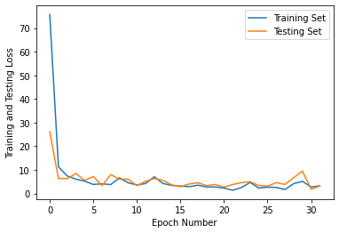

|  |
| --- |
| plt.xlabel('Epoch Number') |

In [23]:

plt.ylabel('Training and Testing Accuracy') plt.plot(model.history.history['categorical_accuracy'], label='Training Set') plt.plot(model.history.history['val_categorical_accuracy'], label='Testing Set') plt.legend()

<matplotlib.legend.Legend at 0x252ef7cf430> Out[23]:

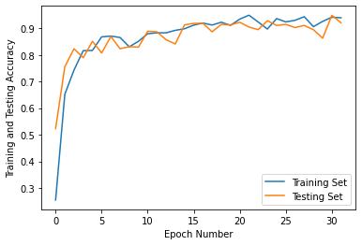

### Saving the model

|  |
| --- |
| model_name = 'SignLanguage_recognition_inceptionv3.h5' model.save(model_name, save_format='h5') |

In [24]:

|  |
| --- |
| model_json = model.to_json() with open("model.json", "w") as json_file:  json_file.write(model_json) |

In [25]:

### Testing the model's accuracy on the testing dataset

|  |
| --- |
| test_set = test_datagen.flow_from_directory(test_path,  target_size = (224, 224), batch_size = 32,  class_mode = 'categorical', shuffle=False) |

In [17]:

Found 503 images belonging to 36 classes.

|  |
| --- |
| predictions = model.predict(test_set) |

In [30]:

16/16 [==============================] - 36s 2s/step

|  |
| --- |
| y_pred = [np.argmax(p) for p in predictions] y_true = test_set.classes  print("False predictions are: ") for i in range(len(y_pred)):  if(y_true[i]!=y_pred[i]):  print('index = {0:2d}, True class => {1}, {2} <= Predicted class'.format(i |

In [24]:

False predictions are:

index = 22, True class => 1, D <= Predicted class index = 26, True class => 1, Z <= Predicted class index = 65, True class => 4, 5 <= Predicted class index = 75, True class => 5, 4 <= Predicted class index = 224, True class => G, Z <= Predicted class index = 230, True class => G, Z <= Predicted class index = 293, True class => K, Z <= Predicted class index = 294, True class => K, F <= Predicted class index = 298, True class => L, 8 <= Predicted class index = 332, True class => N, M <= Predicted class index = 334, True class => N, M <= Predicted class index = 338, True class => O, 0 <= Predicted class index = 342, True class => O, 0 <= Predicted class index = 348, True class => O, 0 <= Predicted class index = 390, True class => R, U <= Predicted class index = 392, True class => S, T <= Predicted class index = 403, True class => S, T <= Predicted class index = 405, True class => S, N <= Predicted class index = 415, True class => T, A <= Predicted class index = 434, True class => V, 2 <= Predicted class index = 435, True class => V, 6 <= Predicted class index = 436, True class => V, Z <= Predicted class index = 441, True class => V, Z <= Predicted class index = 445, True class => V, D <= Predicted class index = 449, True class => W, 6 <= Predicted class index = 451, True class => W, 6 <= Predicted class index = 458, True class => W, 6 <= Predicted class index = 460, True class => W, 6 <= Predicted class

### Plotting the Confusion Matrix

|  |
| --- |
| %matplotlib inline  cm = confusion_matrix(y_true, y_pred) plt.rcParams['figure.figsize'] = (20,20) plt.rcParams['font.size'] = 15  display_cm = ConfusionMatrixDisplay(cm, display_labels=label_names) display_cm.plot(cmap='magma')  plt.xticks(fontsize=15) plt.yticks(fontsize=15) plt.ylabel('True label') plt.xlabel('Predicted label') plt.title('Test Case Confusion Matrix', fontsize=20) plt.show() |

In [22]:

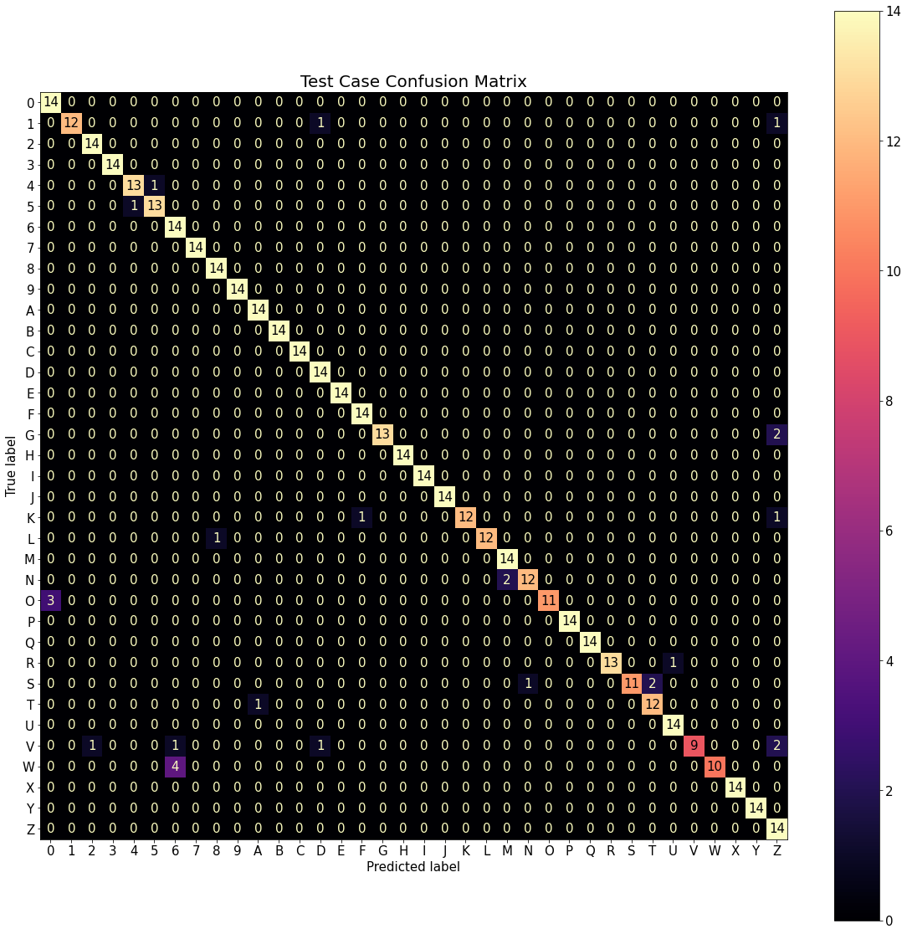

### Evaluating the model

|  |
| --- |
| model.evaluate(test_set) |

In [23]:

16/16 [==============================] - 60s 4s/step - loss: 3.9102 - categorical_ accuracy: 0.9264

[3.9102275371551514, 0.9264413714408875] Out[23]:

* + - Hence we have created a model that recognizes the hand sign Language with an accuracy of 93.28% and a loss of 3.57%. The model can be improved.This model can predict the signs much accurately with image dataset and with a live Video set.
  + The trained model can be used to identify the sign language letter and numbers.The model can be deployed in any application or a website to make it more user friendly

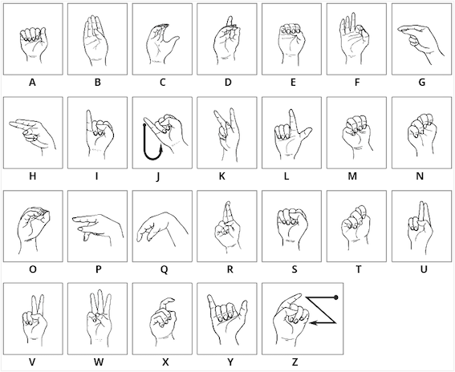

By :

GOKUL HARI R

KNOWLEDGE INSTITUTE OF TECHNOLOGY

EMAIL ID: 2k20cse029@kiot.ac.in